**Evaluate the Performance of an E-learning Application Using Jmeter**

Description

As a Test Engineer, you are asked to develop an evaluation test for users logged into an e-learning application.

**GitLink: https://github.com/surajmalwankar/JMeter**

**SOURCE CODE WITH SCREENSHOTS:**

Step1: Records some steps of Simplilearn Page using Blazemeter because Jmeter is not allowing to record the steps of Simplilearn website

(Steps are: Go to HomePage of Simplilearn,

Then Click on Login,

Then Click on Signup )

Step2: After stop the recording, Save the file -> This recorded file will be saved in our downloads folder

Step3: Open Jmeter

Step4: Open that recorded file by Jmeter(Go to open folder in Jmeter -> From there, select the recorded file and open it) -> It will open in Jmeter like as shown below:

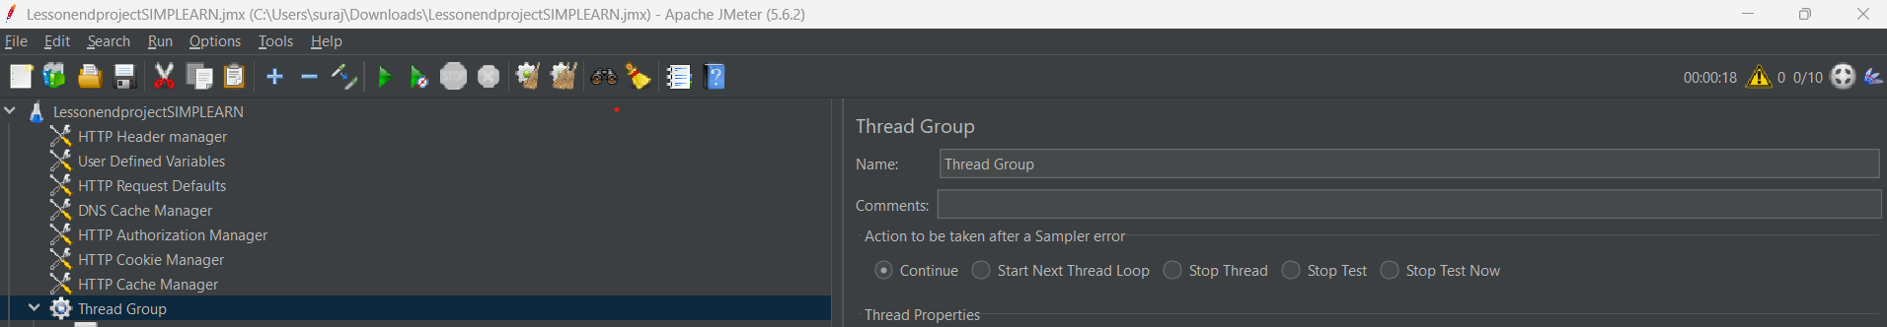

Step5: Right click on Thread Group(In Thread Group, Give the number of users as 20) -> Add -> Logic controllers -> Add three Simple controllers

Step6: Then, put the Homepage script in one Simple controller , Login script in another Simple controller and Register page script in another Simple Controller as shown below:

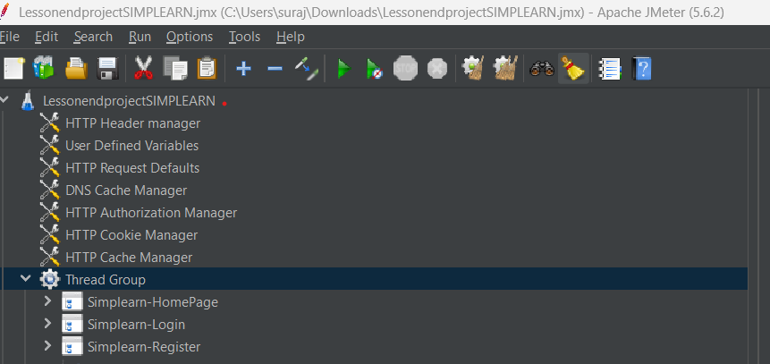

Step7: Right click on all three Simple Controllers and “Apply Naming Policy”

Step8: Right click on Homepage Simple Controller -> Add -> Assertions -> Response Assertion

Step9: In Response Assertion, Give the details as shown below:

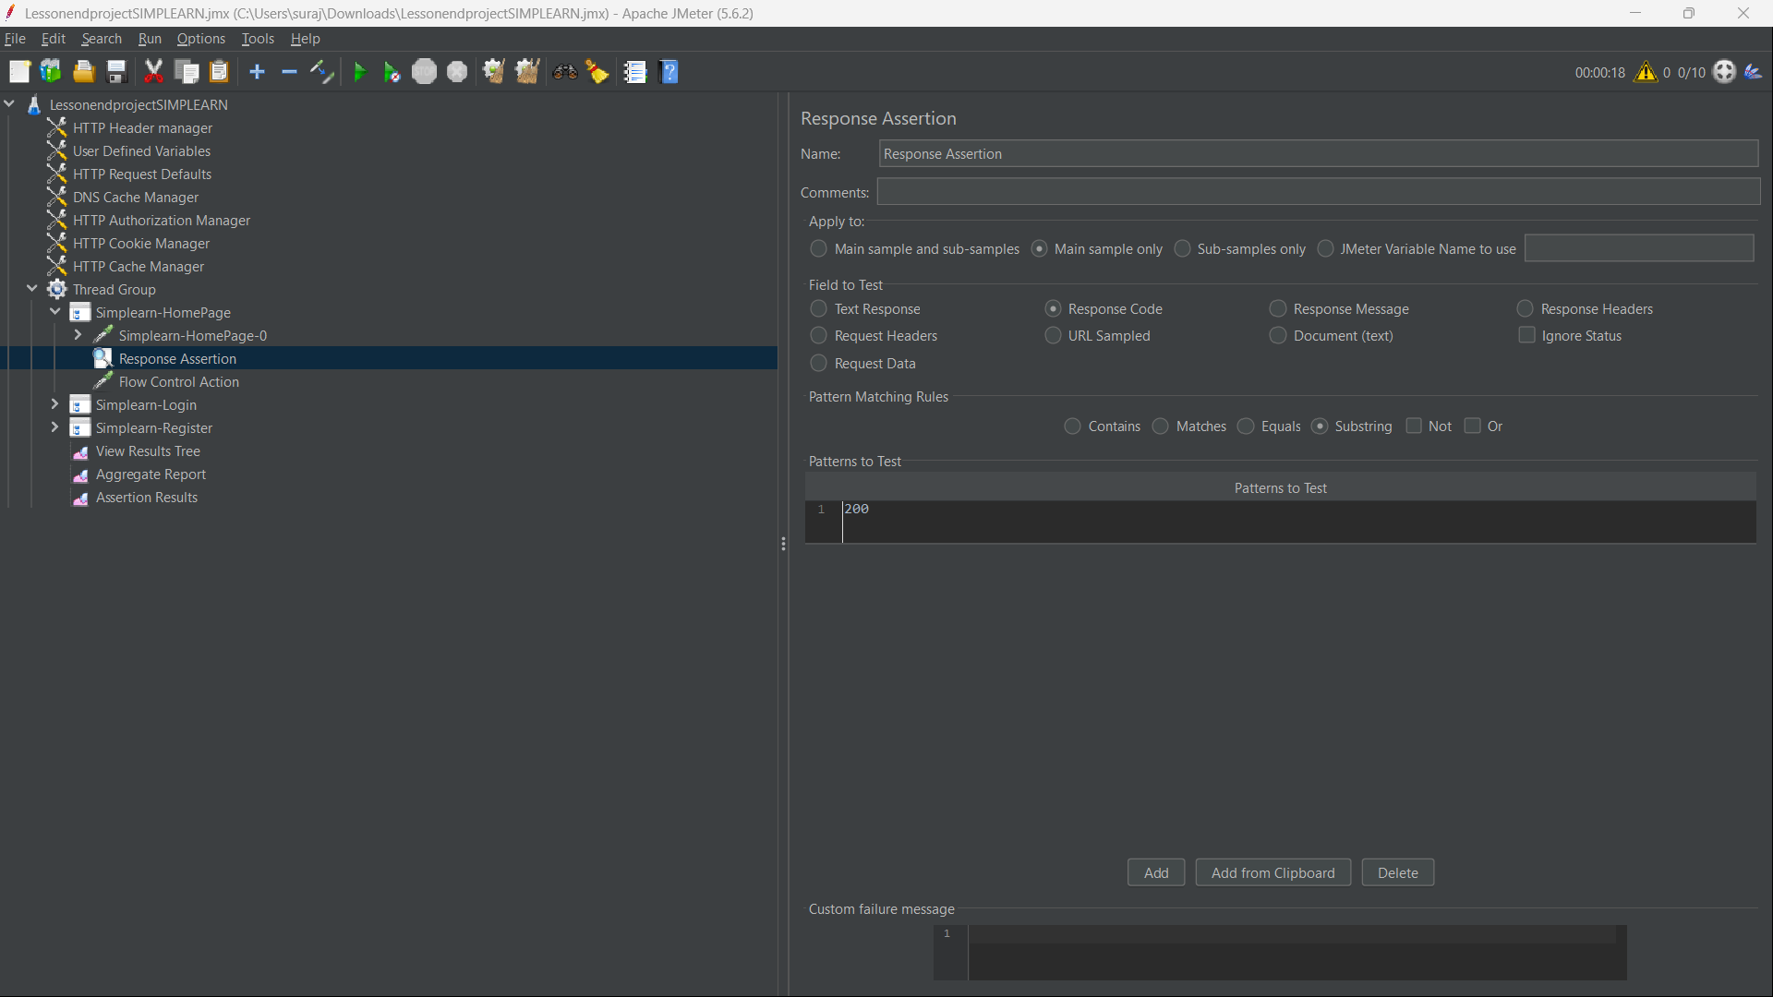

Step10: Right click on Homepage Simple Controller -> Add -> Sampler -> Flow Control Action (for the wait time)

Step11: In Flow Control Action, Give the wait time of 500 milliseconds in “Duration”

Step12: Right click on Loginpage Simple Controller -> Add -> Assertions -> HTML Assertion

Step13: Now, Create a New folder in our Desktop folder where we already saved all Jmeter Scripts -> Inside this new folder -> Create a new text document file

Step14: Open Jmeter, In HTML Assertion, Browse the whole path of that new text document file in “Fiename” as shown below:

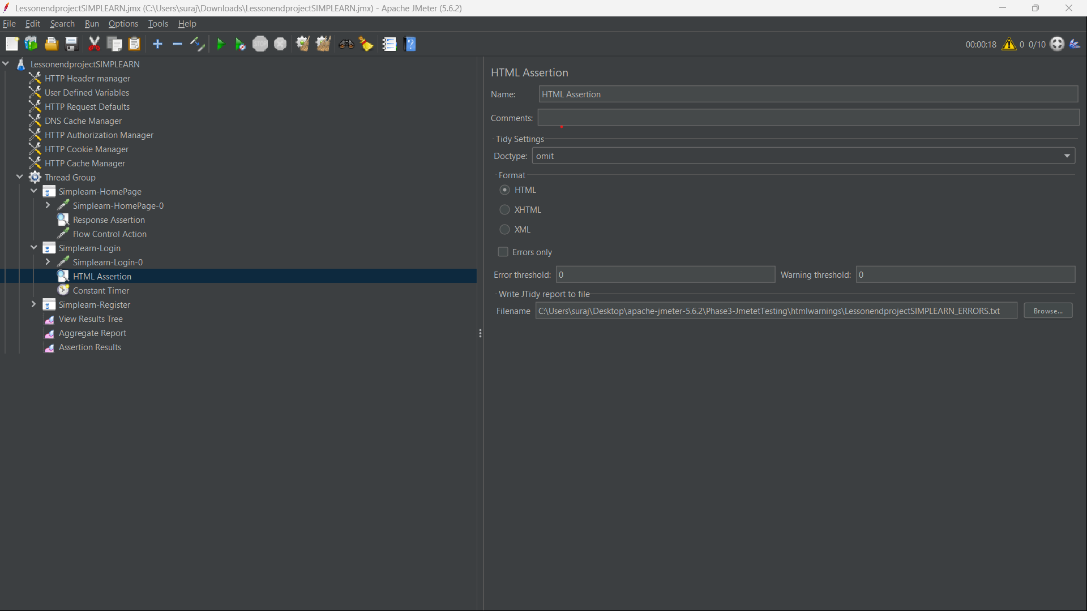

Step15: Right click on Loginpage Simple Controller -> Add -> Timer -> Constant Timer

Step16: Right click on Registerpage Simple Controller -> Add -> Assertions -> Duration Assertion

Step17: In Duration Assertion, Give the Duration of “5000 milliseconds”

Step18: Right click on Registerpage Simple Controller -> Add -> Timer -> Constant Timer

Step19: Right click on Thread Group -> Add -> Listener -> View Results Tree (to see the output)

Step20: Right click on Thread Group -> Add -> Listener -> Aggregate Report (to see the report of output)

Step21: Right click on Thread Group -> Add -> Listener -> Assertion Results (to see the assertion result)

View Results Tree:

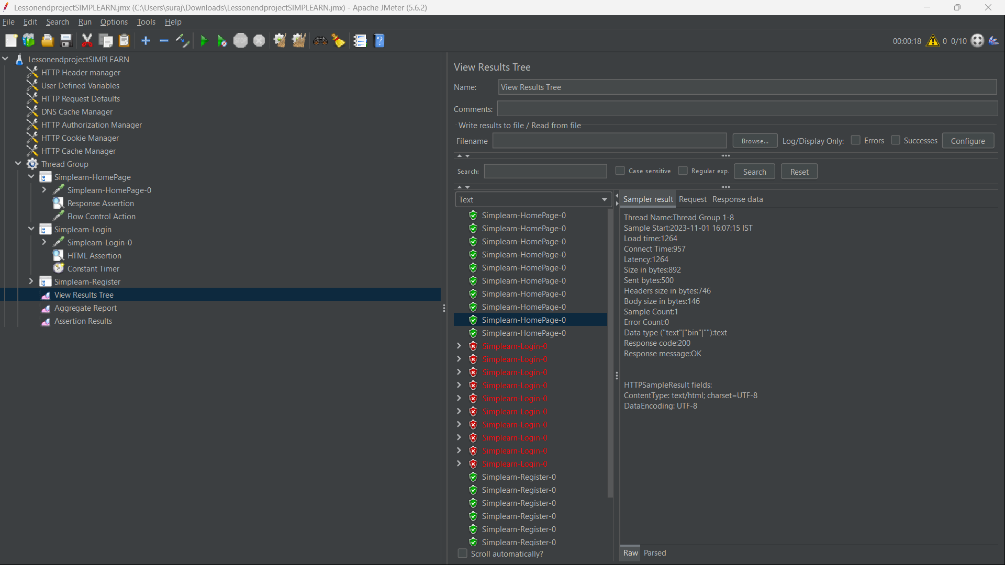

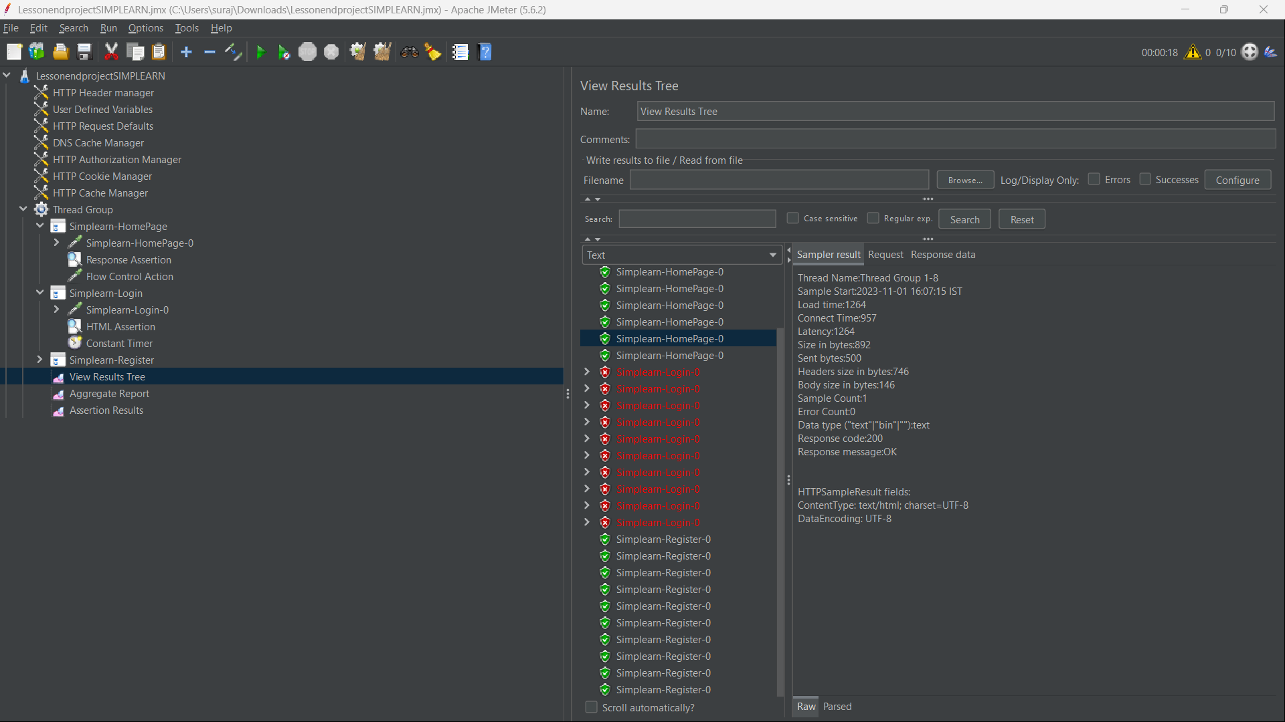

Aggregate Report:

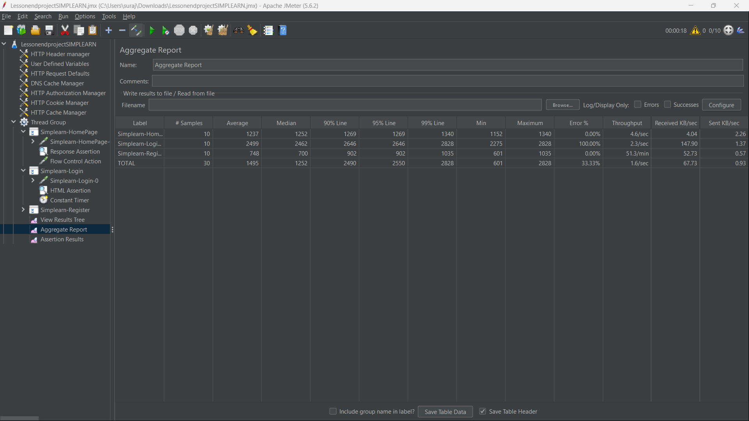

Assertion Results:

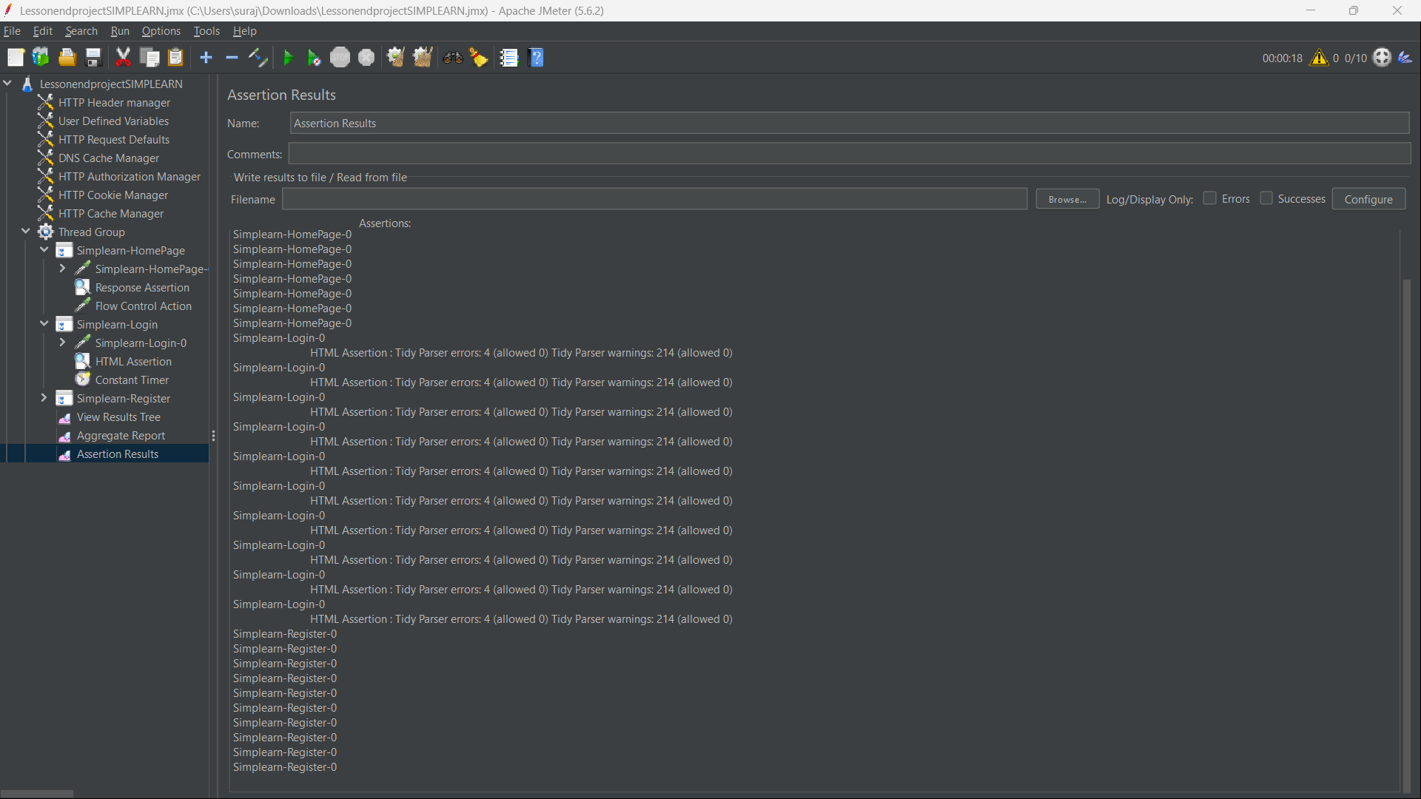

Errors and Warnings File that we have recorded for Simplilearn page:

